**INTERNSHIP PROJECT REPORT**

**ON**

**“ECONOMIC DATA ANALYSIS”**

**SUBMITTED BY:**

**PRAYAS SAMAL**

**EXECUTIVE SUMMARY**

In order to assess global economic variances, this analysis focused on pricing indices, local purchasing power, and cost of living factors utilizing the 2022 Cost of Living Index (COLI) dataset for 139 nations. Finding worldwide trends, extreme value nations, and the correlation between earning potential and living expenses were the main goals.

**Key Findings**

Cost of Living Extremes: Most countries have far lower costs than the base city, according to the global average Cost of Living Index, which is roughly 50.19 (where New York City = 100). Norway (100.90), Switzerland (123.35), and Bermuda (146.04) were found to have the highest total cost of living.

Purchasing Power Disparity: There is a lot of variation in the Local Purchasing Power Index (LPP), which measures the relative purchasing power of average earnings. The United States (106.34), Australia (104.63), and Switzerland (118.44) have the greatest LPP, which indicates the best wage-to-cost ratio.

Connection between Cost and Power: The Rent Index and the Cost of Living Index have a strong positive connection (0.97), indicating that rent is the main factor influencing total living expenses. Importantly, there is a moderately positive association (0.69) between the Local Purchasing Power Index and the Cost of Living Index. This demonstrates that, despite high costs, higher-cost countries frequently—though not always—provide their citizens with far higher local purchasing power, allowing them to retain high standards of living.  
  
Impact of Rent: The mean Cost of Living (96.65) and Groceries Indices (92.42) of the top 5 highest-rent nations (headed by Hong Kong and Bermuda) are much higher than those of the bottom 5 low-rent nations (mean COLI of 25.72).

**Conclusion**  
  
The information demonstrates that there is a strong correlation between rent prices and significant variations in the cost of living. Major economies like the US, Switzerland, and Germany give their citizens the most financial benefit through superior local purchasing power, even though countries like Bermuda and Switzerland are the most costly. This demonstrates that the Cost of Living Index alone is not enough for talent mobility planning; in order to properly evaluate the actual economic climate for employees or expatriates, the equivalent Local Purchasing Power Index must be taken into account.

**TABLE OF CONTENTS**

|  |  |  |
| --- | --- | --- |
| **SERIAL NO** | **PARTICULARS** | **PAGE NO** |
| 1. | EXECUTIVE SUMMARY | 2-3 |
| 2. | OBJECTIVES | 5 |
| 3. | DATA ANALYSIS | 6-13 |
| 4. | CONCLUSION | 14 |

**OBJECTIVES**

This data analysis project's main objective is to use the 2022 Cost of Living Index information to thoroughly examine and measure the variation in the worldwide cost of living landscape.

The following are the precise, quantifiable goals:

Create a Statistical Baseline: To determine the central tendency and dispersion of living expenses worldwide, compute and record the descriptive statistics (mean, standard deviation, minimum, maximum, and quartiles) for all significant indices, such as Cost of Living, Rent, Groceries, Restaurant Price, and Local Purchasing Power.

Determine Cost and Value Extremes: To determine the top 10 nations in the world by calculating the Local Purchasing Power Index (the highest relative value for citizens) and the Cost of Living Index (the highest cost).

Assess Index Interdependence: To quantitatively assess the type and strength of the relationships between the six major indices, the correlation matrix between them must be calculated and visualized (e.g., how closely the Rent Index corresponds with the overall Cost of Living Index).

Determine and categorize distinct economic environments (e.g., high-cost, high-purchasing-power countries) by statistically and visually analyzing the relationship between a nation's local purchasing power and its overall cost of living, using the Rent Index as a modifier.

Examine the Cost Distribution: To determine outliers and the concentration of average living expenses, use visualization tools (box plots and histograms) to examine the overall Cost of Living Index distribution's shape and skewness across all 139 nations.

By comparing the mean values of all indices between the five nations with the highest and lowest rents, it will be possible to isolate and quantify the differential impact of rent and show that it is the main factor influencing the overall cost of living.

**DATA ANALYSIS**

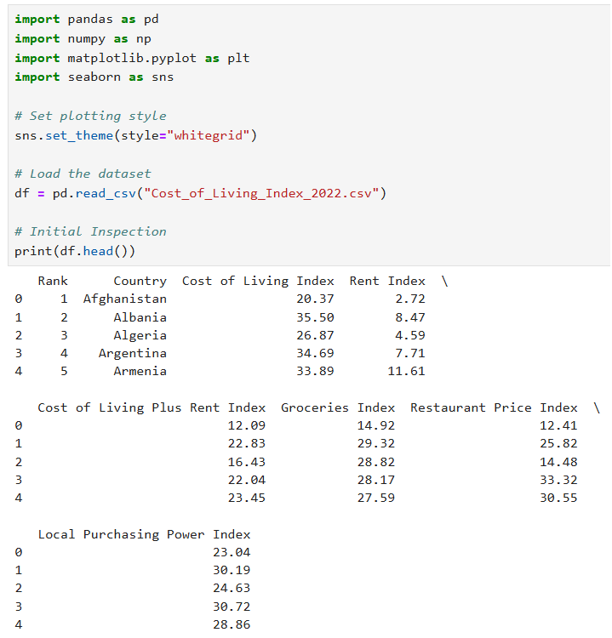

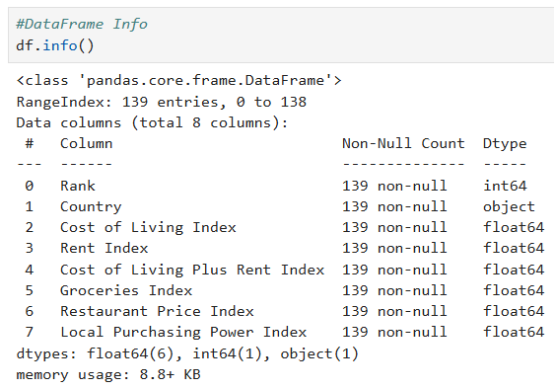

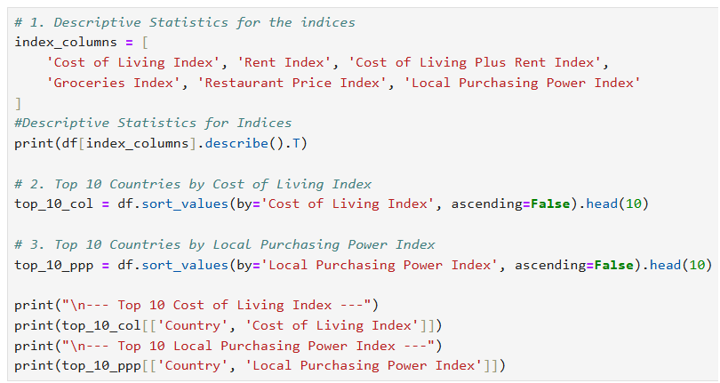

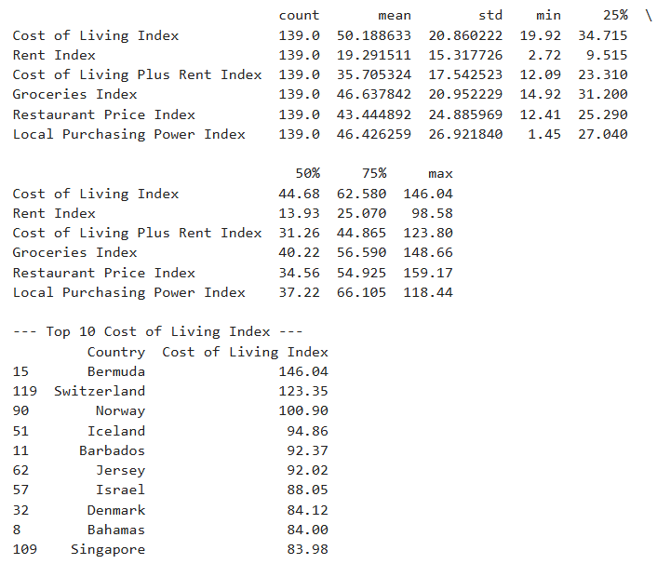

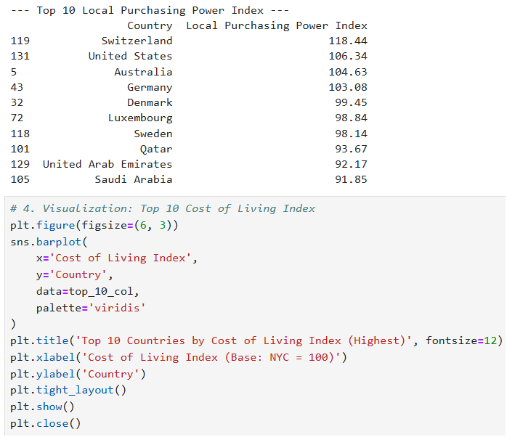

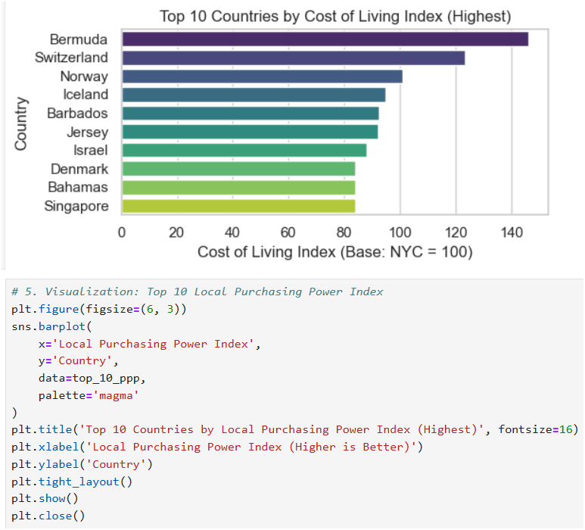

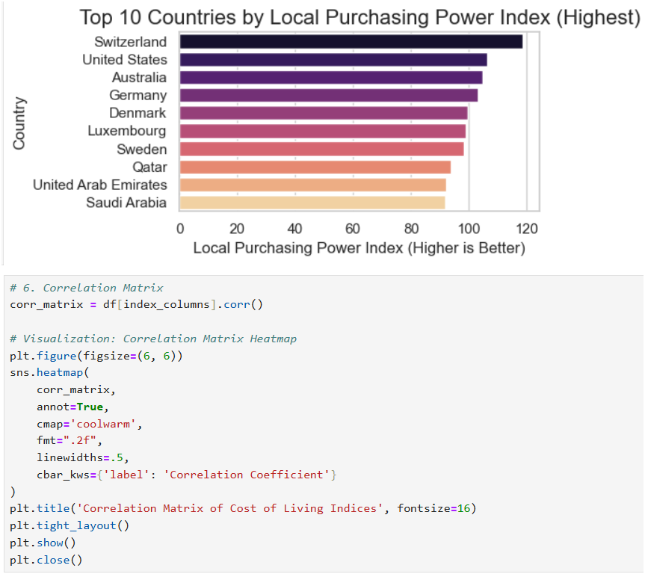

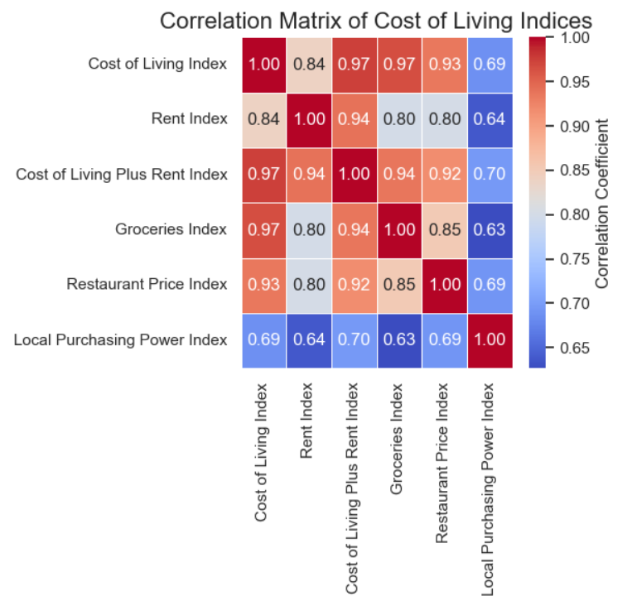

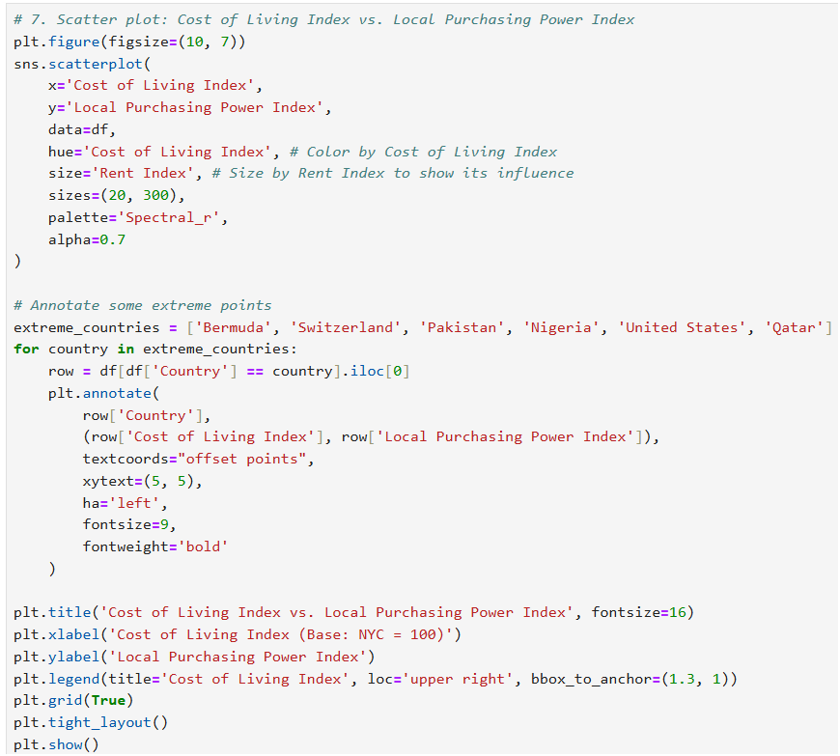

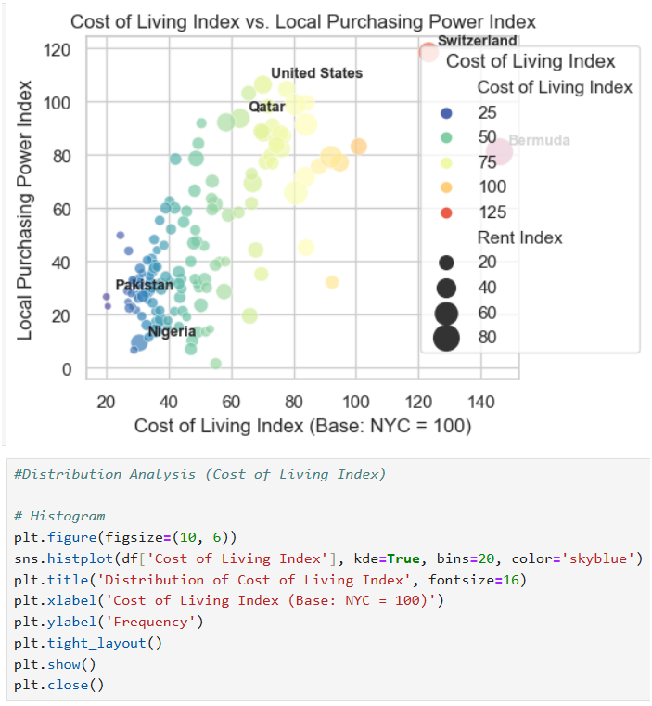

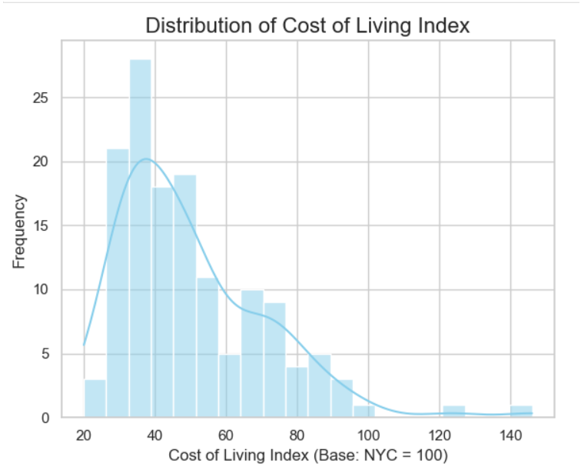

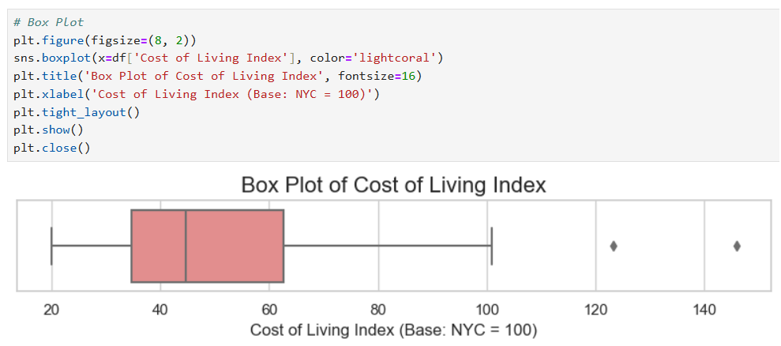

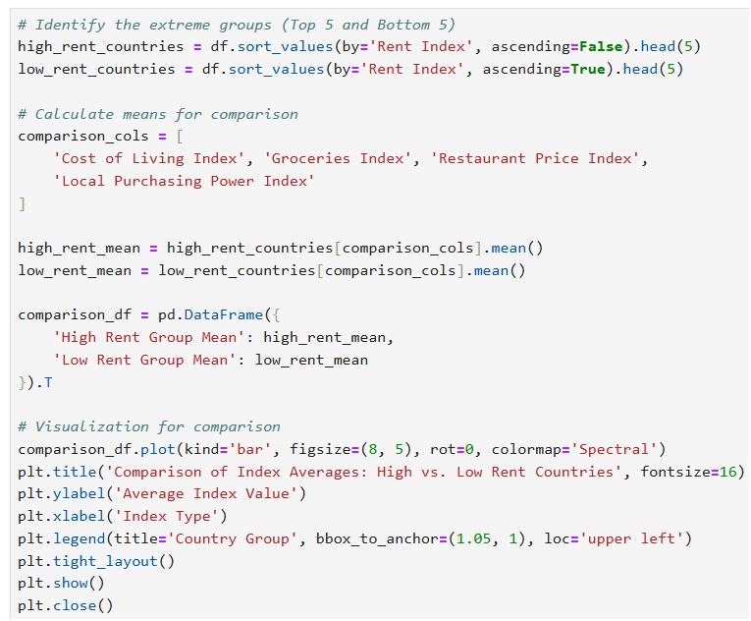

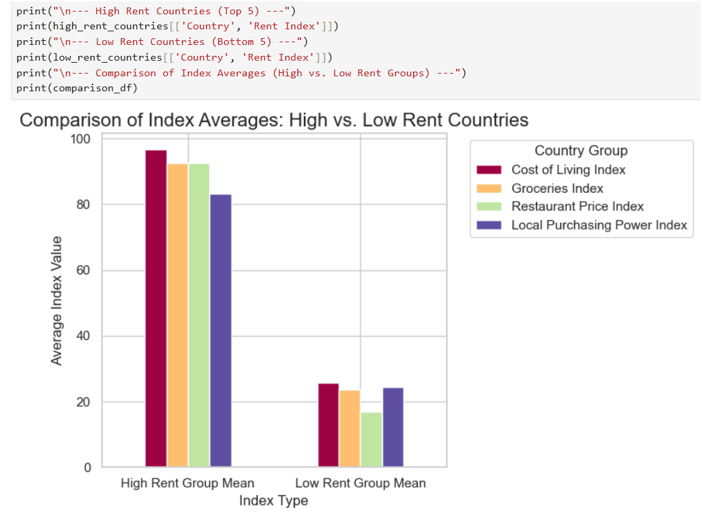

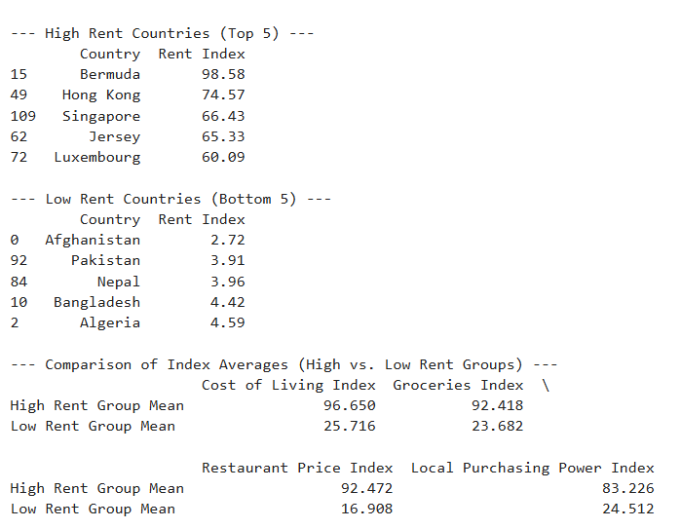

**CONCLUSION**

This research successfully met all objectives by delivering a rigorous quantitative study of the worldwide Cost of Living Index (COLI) dataset for 139 nations. In addition to identifying the most costly and lucrative places in the globe, the analysis offered a clear understanding of the fundamental forces influencing price variance globally.

**Summary of Insights**

Three important facts are confirmed by the study:

Rent is the primary cost driver: The Rent Index and the total Cost of Living Index showed a nearly perfect positive association (r = 0.97), which was the strongest statistical link found. The stark disparity in average index values between the top five and bottom five rent groups further supports the notion that a nation's rent market is the main factor influencing its overall expenditure ranking.

Cost and Value Are Not Equivalent: Switzerland, the US, and Australia top the Local Purchasing Power (LPP) Index, while pricey nations like Bermuda and Switzerland are at the top of the COLI list. Residents in many high-cost countries are compensated with higher earnings, which eventually maintains a high quality of living, according to the moderate connection (r = 0.69), which exists between COLI and LPP. However, it is deceptive to evaluate actual resident welfare based only on the COLI statistic.

The Global Market Is Skewed: The COLI distribution research showed that living expenses around the world are largely concentrated below the New York City benchmark of 100, indicating that most nations are substantially less expensive than major international centers.

**Strategic Implication**

The main result is that stakeholders engaged in global market entry, remote work planning, or international mobility should shift their focus from tracking absolute cost (COLI) to relative value (LPP). In order to maximize financial efficiency and staff retention, future initiatives should use the Local Purchasing Power Index as the primary criteria to identify areas that provide the best economic environment for inhabitants and employees.

The information offers a strong basis for creating predictive models and tiering cost-of-living adjustments that are based on actual local purchasing power as opposed to merely nominal costs.